Novoferm takes over French Manugestion Group
Rees, 2 November 2021. With the takeover of the Manugestion Group, Novoferm, one of the leading European system suppliers of door and docking solutions, is resolutely continuing to strengthen its position on the French market.
Within the Manugestion Group, Manuregion is a company established on the market which specialises in the installation, maintenance and repair of industrial doors and docking systems. The business was founded in 1989, has 120 employees at seven sites in the north-east of France and generates an annual turnover of 25 million euros.
For Novoferm, the acquisition is an important step in the continuing expansion of the activities of the Novoferm Group across Europe. Manuregion has steadily grown in recent years as a result of its customer-focused range of services and has acquired a strong position in its catchment area.
Manuregion will be integrated into the existing organisation of Novoferm France in the future under the leadership of Eric Drain and Stéphane Keyser, the current majority shareholders. Rainer Schackmann, CEO of the Novoferm Group, is pleased about the acquisition and believes that Manuregion and Novoferm complement each other perfectly: “By integrating Manuregion into the Novoferm Group, Novoferm can support its customers in the North-eastern French market even better with all the services associated with the installation, maintenance and repair of industrial doors and docking systems. This way, Novoferm will be creating the ideal conditions for further growth and strengthening its position in France.”

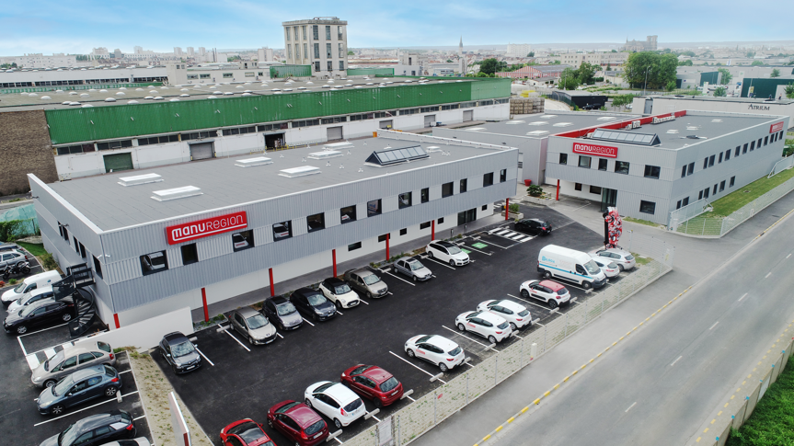

> photo: Novoferm <

About Novoferm
Novoferm has been part of the Japanese Sanwa Group (owned by Sanwa Holdings Corporation), the world market leader in the field of hinged door and garage door systems, since 2003. Novoferm is one of the leading European system suppliers of door, garage door solutions and docking systems for private, commercial and industrial use, with over 3,200 employees in Europe. Established in 1955 on the Lower Rhine, the company today has production plants in various European locations and sells products in many countries worldwide through numerous subsidiaries and sales partners.

Press contact

Novoferm Vertriebs GmbH
Heike Verbeek
Schüttensteiner Straße 26
46419 Isselburg (Werth)

tel. +49 (0) 28 50. 9 10 -4 35
heike.verbeek@novoferm.de
www.novoferm.de

